# CEN4010 Principles of Software Engineering

### Spring 2021

# Milestone 1 Project Proposal and High-level Description

## Group 2: Team Rocket

## Project name: *Apollo Melodies*

### Team Members

Ivan Bruno-Gaston (Product Owner) - ibrunog@fau.edu

Craig Peroni (Scrum Master) - cperoni2020@fau.edu

Sharmada Iyer (Developer) - siyer2018@fau.edu

Belal Mahmood (Developer) - bmahmood2018@fau.edu

Isabel Tait (Developer) - itait2017@fau.edu

### Date: 2/16/2021

|  |  |
| --- | --- |
| Revision Number | Date |
| 1.0 | 2/16/2021 |

1. Executive Summary

**Introduction**

Listening to music is a hobby to many people. Many music platforms allow users to enjoy music uploaded by several artists. However, most of these platforms rarely use music as a fun and competitive interaction. The COVID-19 pandemic has restricted outdoor fun activities. The internet consists of games that are fun and competitive but only very few incorporate music. The purpose of this project is to use music in the form of a game to unleash a competitive environment between users.

**Objectives**

* To provide a fun game-based platform that unleashes a competitive environment with the use of music.
* Allows users to create an account and keep track of their high scores while giving them the option to compete with other users on the platform.
* Provide a variety of genres and difficulty levels for the user to choose from.

**Target Customers**

* People who listen to music as a hobby - Individuals can put their music knowledge to the test by taking the music quiz on any genre they so desire.
* Families - Especially due to the COVID-19 Pandemic, families have not been able to engage in outdoor activities. This platform can be a great game to play on family game nights or occasions.
* Individuals looking to expand knowledge on music - There is no required knowledge necessary to play the game. This platform is a great way to expand knowledge on music and even receive recommendations.

**Value Proposition**

Apollo Melodies fills in the need of having a game-based platform that is tailored towards music. It is a platform that can be played by individuals of all ages and different music tastes. Users will have the option of either playing a single player, single player competing with other users, or multiplayer to play on game nights or other occasions.

**Application Features and Descriptions**

Games can be played without having to sign-in. However, in order to be on the leaderboard and compete with other people, users are required to sign in. The user can select the genre as well as the range of difficulty. The game will play snippets of audio as a question and will be asked multiple choice questions on the audio snippet (e.g. Who is the artist of this song?).

2. Competitive Analysis

|  |  |  |  |  |  |  |
| --- | --- | --- | --- | --- | --- | --- |
|  | Single Player | Multiplayer | Music player(Specifically for questions) | All Ages | Free | Fast Paced |
| Apollo Melodies | ✅ | ✅ | ✅ | ✅ | ✅ |  |
| Competitor 1  (Kahoot) | ✅ | ✅ |  | ✅ | ✅ | ✅ |
| Competitor 2  (Quizlet Live) | ✅ | ✅ |  | ✅ |  | ✅ |
|  |  |  |  |  |  |  |

Summarize advantages or competitive relationships to what is already available.

Kahoot and Quizlet have been used countless times over the years by many different people, whether it be for fun or studying. Instead of questioning social knowledge in Quizlet or Kahoot, Apollo Melodies brings a spin to the competition by testing music knowledge. Quizlet Live is Quizlet’s newest feature that allows for multiplayer platforms.

Kahoot is one of the most widely used applications for interactions in school between professors and students. It has been known to help students with retaining knowledge for years. While Kahoot is widely used it has been said that it can be a bit too fast paced for students to answer questions; leaving some students, who aren’t so sure, feeling negative. Kahoot also doesn’t use actual music on the website except for background music. In Apollo Melodies, there is a music player that plays a small snippet for the user to listen to and answer a question about the snippet afterwards.

Quizlet Live is a new feature that allows users to remotely engage with other users to play games. Quizlet has been around for many years and has been used in numerous different surroundings from school to companies. Quizlet allows users to use premade cards or make new cards. Quizlet Live is a fast paced environment that tests user social knowledge. In order to have a Quizlet Live account you have to be either a teacher or parent and also pay after a 7-day free trial. Apollo Melodies doesn’t charge for usage, allows any institutions to use it, and is meant to have the user feel like they are having fun rather than fast pace.

3. Data Definitions

**Music Quiz**

* **Alias**: None
* **Description:** A series of multiple choice questions related to the series of songs that are played on the webpage.
* **Related Data Items:** None
* **Range of Values:** Not applicable

**Score**

* **Alias:** None
* **Description:** The total amount of points a user has achieved on the quiz which is stored in their profile database.
* **Related Data Items:** Score must always be equal to the total number of points the user has accumulated during one quiz.
* **Range of Values:** 0 - 100

**Point**

* **Alias:** mark
* **Description:** When the user answers a question correctly, they accumulate a certain number of points. When they don’t answer the question correctly, they either do not gain points or their score may be lowered.
* **Related Data Items:** The total number of points must be equal to the user’s score.
* **Range of Values:** 0 - 100

**Player**

* **Alias:** participant, contestant, competitor
* **Description:** An actor who is actively engaging with a music quiz.
* **Related Data Items:** A player takes a music quiz and gains points that contributes to their score if they answer any questions correctly.

**API (Application Programming interface)**

* **Description:** For the purpose of this project, API signifies any programming tool provided by third party to allow a developer to use that third party’s resources on the developer’s site.

**LAMP Server**

* **Description:** Any web server which implements Linux, Apache, MySQL, and PHP (L.A.M.P).

**“Eye-Level” Graphical User Interface (GUI or UI)**

* **Description:** This is the front end (A.K.A client facing) of the site which describes all of the elements of the application that the user can see and use.

4. Overview, Scenarios, Use Cases

*4.1 - Scenario 1*

John went to go test for COVID-19 last Friday. He ended up testing positive so he began his quarantine. At first he accomplished all the things he didn’t do then he began to get really bored. He has a strong interest in music and decided to check out Apollo Melodies to test his knowledge on music. He scrolled through and saw the genre he was comfortable with and began to play a game where they test your knowledge about a song lyric or short clip of. He enjoys the product.

*4.2 - Scenario 2*

Kate and Jill were having a competition about who knew the most songs. They go to Kate’s house and go to Apollo Melodies to play. They listen to quick snippets of songs and answer the questions that follow. They keep track and see who wins.

5. Initial High-Level Functional Requirements

1.

1.1

2.

2.1

6. List of Non-Functional Requirements

*6.1 Security*

Since the application is not expected to contain any Personally Identifiable Information (P.I.I.) and will not facilitate any financial transactions, security risk to the site is considered to be low. Therefore a moderate level of password encryption will be used to encrypt password data. Passwords must contain at least 9 characters with upper and lower characters. A number must also be included in the password for it to be accepted.

Validation of passwords based on password rules will be accomplished with JavaScript on the front end of the app. The encryption algorithm will be executed in PHP on the server-side of the application.

*6.2 Usability*

The target customer for this application will be a user with moderate computing skills. The user should not need advanced computing skills in order to use the product. GUI design should be simple and screen hints should be available to guide users through the process

*6.3 Reliability*

User volume on this application is not expected to be high and, thus server up-time is considered to be moderately critical. The expected downtime (other than hardware failures) will likely be due only to pushing new implementations of the product from the development environment to the production environment. Dev-to-Prod pushes are expected to bring the site offline no more than 5 minutes. Dev-to Prod pushes will be off-cycle throughout the duration of the project. However, these pushes will take place after hours.

6.4 Maintainability

Admin users will be created for this site. Admin users will have the ability to make basic configuration changes to the site, and manage regular users on the site. An admin user should be able to make basic configuration changes to the site through the front end GUI without the need to directly program to an API.

6.5 Performance

* 6.5.1 - **Page Loading Time** - Page loading times should take no longer 90 seconds on a computer or mobile device with a current browser and internet speed of 4G or more
* 6.5.2 - **Concurrent usage** - The site should be able to support at least 1000 concurrent users operating on the site
* 6.5.3 - **UI Responsiveness** - The display should adapt to the size of the viewing port within 10 seconds of full page load.

7. High-Level System Architecture

*7.1 Overview*

In this section of the proposal,we will detail the technology stack used to implement the software solution. All tools from the hardware to the client-facing GUI will be detailed. The supporting technology will be configured as an ecosystem where this or multiple applications (or application components) can share real time access to the underlying databases

*7.2 Hardware*

The hardware which will host the application is a LAMP server provisioned by Florida Atlantic University for our group to use. This Linux server implements Apache, MySQL, and PHP Application development environments. No other hardware will be used.

*7.3 Database Utility*

To build the application databases, we will use the MySQL implementation on the LAMP server. One database will be developed and tables will be created for member data, activities, and administrative needs. This database will be relationally implemented. The unique key and relational key for all database tables will be the unique user ID.

*7.4 Server-Side Scripting*

In order for the application info interface between the client-facing GUI and the database, PHP will be used to perform the server-side scripting. This includes validating and encrypting the user login, creating new users, and adding/modifying content at the user level. Other features which emerge during the progression of the project will also use PHP.

*7.5 Client-Side Scripting*

Any client-side scripting will be done using JavaScript and CSS. This includes animation, front-end form validation, and any other user experience elements.

*7.6 “Eye-Level” Graphical User Interface (GUI)*

The front end GUI for the application will be Coded in HTML5 and CSS by implementing a mobile-responsive Bootstrap template acquired from <https://startbootstrap.com/>. The actual final template chosen will be decided later in the project. Proper credit for the template used will be listed on the site.

*7.7 SoundCloud API*

Soundcloud provides an external API to allow other web applications to access music resources and display them with their site. This code is found at <https://developers.soundcloud.com/docs/api/html5-widget>.

8. Appendix

*8.1 Appendix A - Account Creation Process*

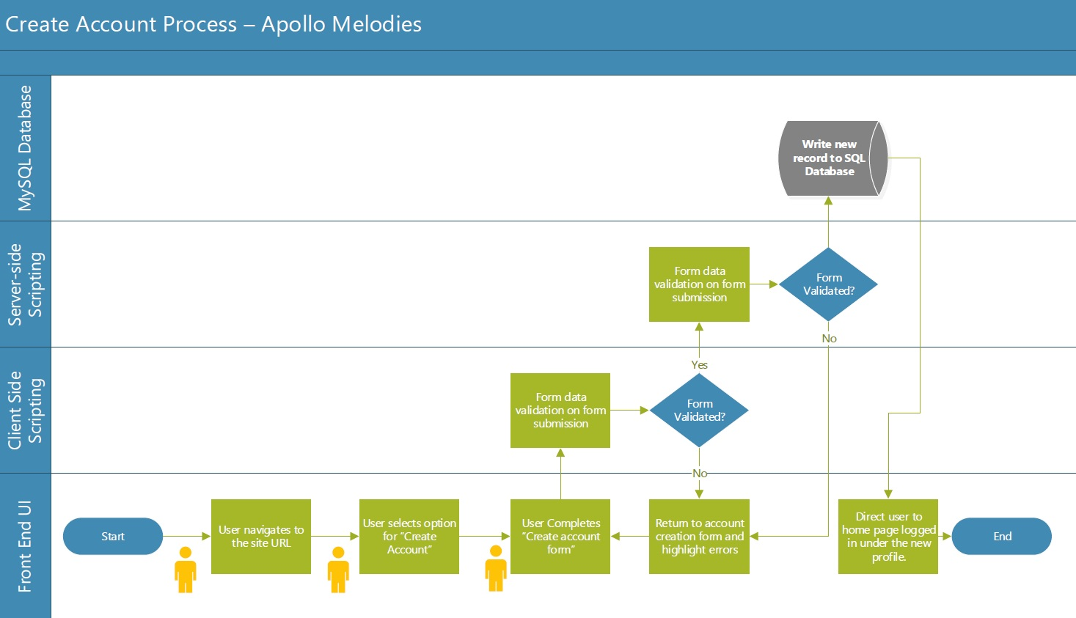

*8.2 Appendix B - Account Login Process*

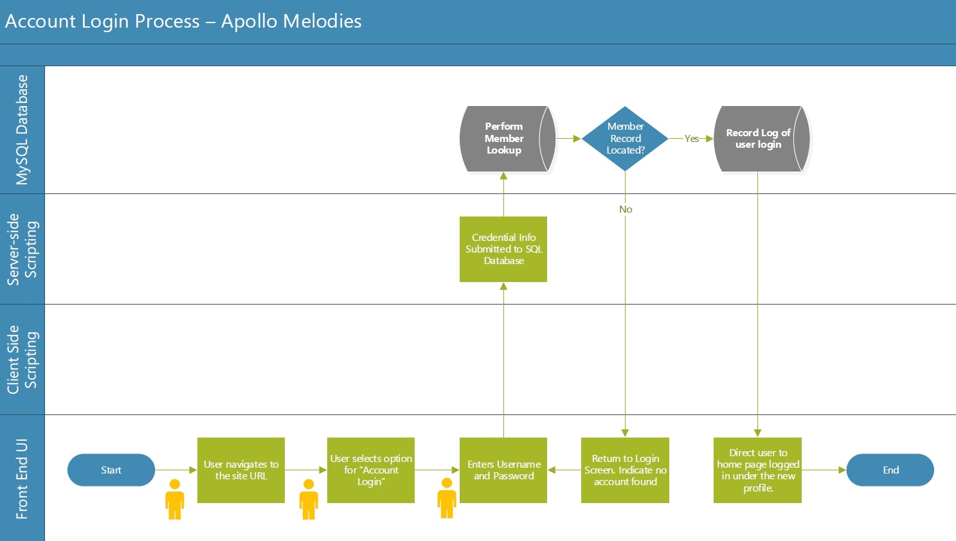

*8.3 Appendix C - Quiz Creation Process*

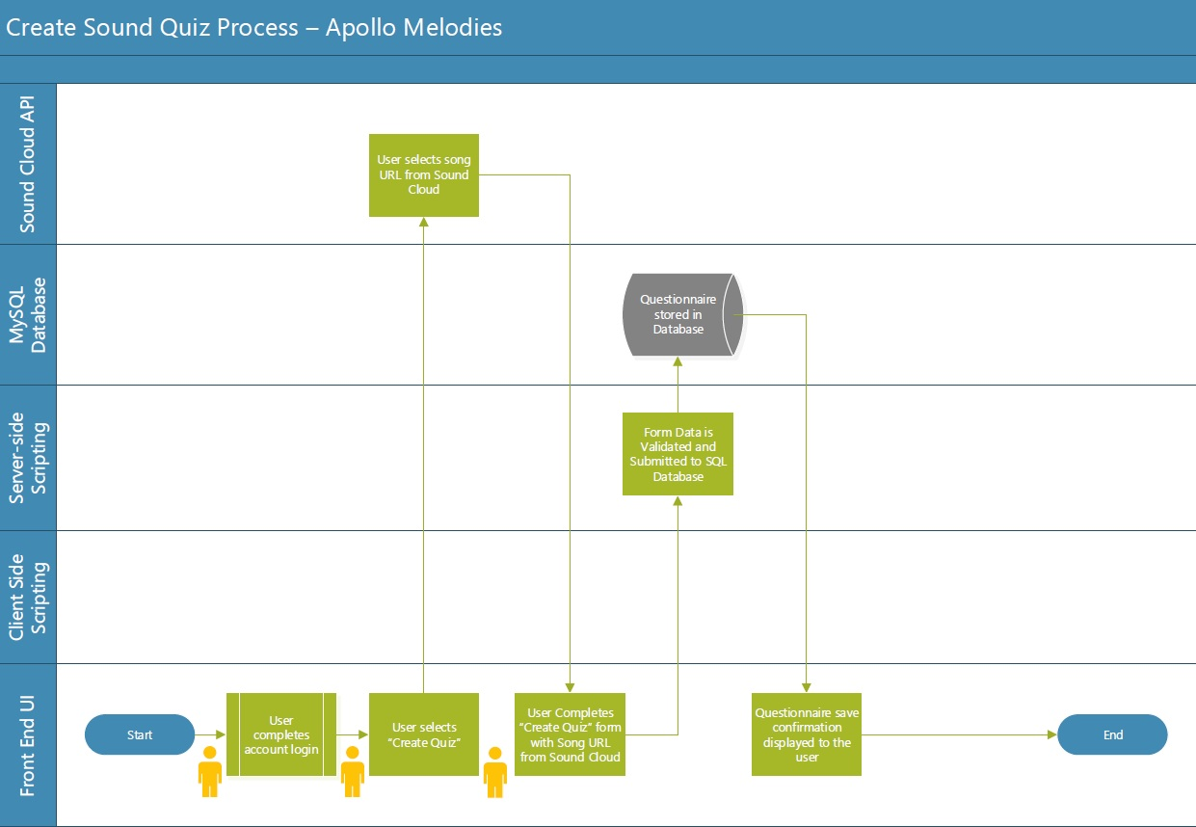

*8.4 Appendix D - Quiz Completion Process*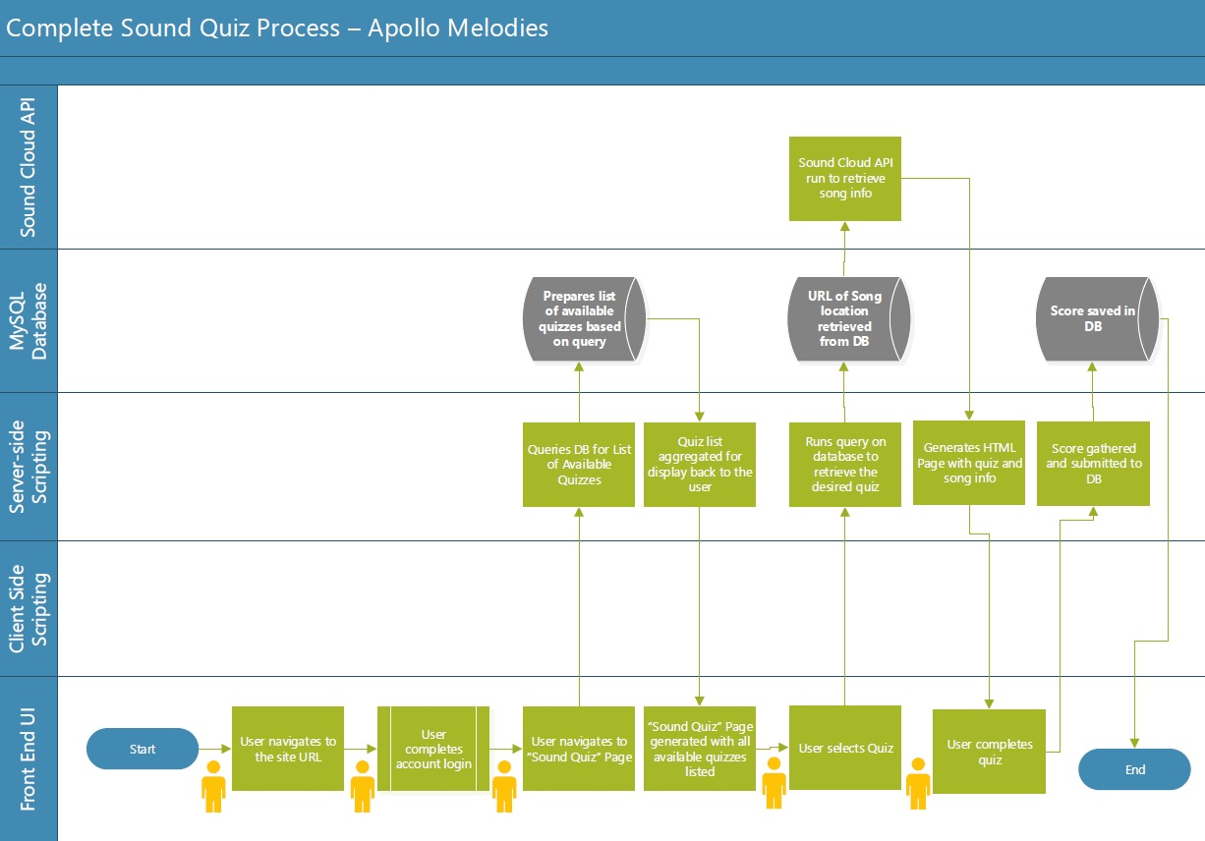

8. Group 2: Team Rocket

Ivan Bruno-Gaston (Product Owner) - [ibrunog@fau.edu](mailto:ibrunog@fau.edu)

Craig Peroni (Scrum Master) - [cperoni2020@fau.edu](mailto:cperoni2020@fau.edu)

Sharmada Iyer (Developer) - [siyer2018@fau.edu](mailto:siyer2018@fau.edu)

Belal Mahmood (Developer) - [bmahmood2018@fau.edu](mailto:bmahmood2018@fau.edu)

Isabel Tait (Developer) - [itait2017@fau.edu](mailto:itait2017@fau.edu)

About Us

<https://lamp.cse.fau.edu/~cen4010_s21_g02/>

9. Checklist

|  |  |
| --- | --- |
| Method of Communication Decided | DONE |
| Team Found a Timeslot to Meet | DONE |
| Front and Back End Team Leads Chosen |  |
| Github Master Chosen | DONE |
| Team Ready/Able to use front/back-end Frameworks |  |
| Skills of Team Members Defined and Known by All | DONE |
| Team Lead ensured final M1 Reviewed by All | On Track |